302 - Flight - Radios, Navigation, Flight Director, Jettison

Radios
COM1 | AN/ARC-164(V) | UHF | 225.000 to 399.975 MHz | AM | Instrument panel
COM2 | AN/ARC-134 | VHF | 116.000 to 151.975 MHz | AM | Right console
- Change active radio with large black knob on AUDIO panel (right console).
ARC-164(V) UHF radio
- UHF radio controls are on left side of front instrument panel.
- Power on by setting Function Dial to MAIN or BOTH.
- Using presets:
  - Frequency Mode Dial ... PRESET
  - Change channel with Preset Channel Selector knob. Channel is shown in small window to left of knob, 20 channels available.
  - Main frequency/channel readout above control panel can show either channel or frequency, use switch to left to toggle.
- Changing preset channel frequencies:
- Select preset channel you want to change.
- Select frequency you want to set the preset to by tuning it on the frequency knobs.
- Open the UHF Cover (white panel above frequency knobs) (scroll up) and press the PRESET button to set selected frequency to selected channel.
- Manual frequency tuning:
- Frequency Mode Dial ... MANUAL
- Set frequency with knobs.
ARC-134 VHF radio
- VHF radio controls are on right console rear.
- Power on by setting Power switch to ON (forward).
- Manual frequency tuning (no presets available):
- Set frequency with knobs.

Navigation
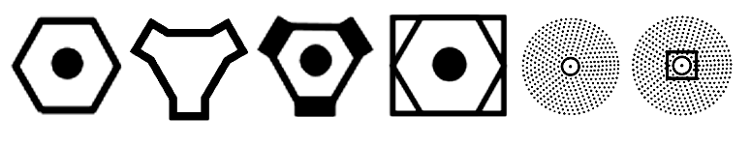 VOR TACAN VORTAC VOR-DME NDB NDB-DME
NDB with ADF receiver
- No ADF receiver on the C-101EB. (UHF radio has an ADF mode, but manual says it's inoperative.)
VOR with VOR-ILS-MB receiver
- On VOR-ILS-MB panel (right console):
  - NAV/VOL knob ... Turn on and adjust volume as desired
  - Tune VOR frequency with tuning knobs.
- Verify NAV button is lit (button to left of HSI), which means it's using the receivers in your cockpit and not the other one.
- Set HSI to VOR (button to left of HSI, toggles VOR/TAC). (Sets source for CDI needle.)
- Set desired course to VOR using Course Select Remote Control knob (course knob on HSI panel on right console rear, or Middle Finger Hat up/down).
- Thin white needle in RMI compass points to VOR beacon. HSI also shows course deviation with displaced yellow line in the middle.
TACAN
- On TACAN panel (right console):
  - Mode knob ... REC, T/R, A/A REC, or A/A T/R as needed
  - Tune TACAN channel with tuning knobs.
- Verify NAV button is lit (button to left of HSI), which means it's using the receivers in your cockpit and not the other one.
- Set HSI to TAC (button to left of HSI, toggles VOR/TAC). (Sets source for CDI needle.)
- HSI will now show distance to TACAN station in top right readout.
- Set desired course to TACAN using Course Select Remote Control knob (course knob on HSI panel on right console rear, or Middle Finger Hat up/down).
- Double-line yellow needle in RMI compass points to TACAN beacon. HSI also shows course deviation with displaced yellow line in the middle.

Flight Director -- TODO
NOTE: Flight Director is not an autopilot, it just provides steering indicators.

Jettison
- Nothing to jettison on the C-101EB.

